Name of Student : Raghav Mahesh Sarda PRN: 25070122235
Subject: Programming with Java Semester: III
ASSIGNMENT No : 3 Year: AY 2026-27
TITLE : Method Overloading and Static Members

Problem Statement
Develop a Java application demonstrating method overloading and the use of static variables, methods in class design.

Learning Objectives
To implement method overloading and use static variables and methods in Java programs.

Program:
Calculator.java
// Assignment 3 - Exercise 1: Calculator using overloaded methods and static variable
import java.util.*;

public class Calculator
{
static int calcCount = 0; // Static variable to count total calculations
public static void add(int a, int b) // Overloaded method for integers
{
calcCount++; // Incrementing count
System.out.println("Integer Sum: " + (a+b));
}
public static void add(double a, double b) // Overloaded method for decimals
{
calcCount++; // Incrementing count
System.out.println("Decimal Sum: " + (a+b));
}
public static void main(String args[]) // Main Method
{
Scanner sc = new Scanner(System.in);
System.out.print("Enter Two Integers: ");
int i1 = sc.nextInt();
int i2 = sc.nextInt();
add(i1, i2); // Calling integer addition

System.out.println("");
System.out.print("Enter Two Decimals: ");
double d1 = sc.nextDouble();
double d2 = sc.nextDouble();
add(d1, d2); // Calling decimal addition

System.out.println("Total Calculations Performed: " + calcCount);
sc.close();
}
}

RestaurantBilling.java
// Assignment 3 - Exercise 2: Restaurant Billing using overloaded methods and static variable
import java.util.*;
public class RestaurantBilling
{
static int totalorders = 0; // Static variable for tracking orders
public static void CalBill(double dinebill) // Function To Calculate Bill For Dine-In
{
totalorders++; // Incrementing order count
System.out.println("Dine-In Bill Amount = " + dinebill); // Displaying bill
}
public static void CalBill(double takebill, double charges) // Function To Calculate Bill For TakeAway
{
totalorders++; // Incrementing order count
double finalbill = takebill + charges; // Calculating total
System.out.println("Take-Away Bill Amount = " + finalbill); // Displaying bill
}
public static void CalBill(double deliverybill, double charges, double deliverycharge) // Function To Calculate Bill For Delivery
{
totalorders++; // Incrementing order count
double finalbill = deliverybill + charges + deliverycharge; // Calculating total
System.out.println("Delivery Bill Amount = " + finalbill); // Displaying bill
}
public static void main(String args[]) // Main Method
{
Scanner sc = new Scanner(System.in);
System.out.println("- Restaurant Billing -");
System.out.print("Enter Dine-In Amount: ");
double amt1 = sc.nextDouble();
CalBill(amt1); // Calling overloaded method for Dine-In

System.out.print("\nEnter Take-Away Amount and Packing Charge: ");
double amt2 = sc.nextDouble();
double pack = sc.nextDouble();
CalBill(amt2, pack); // Calling overloaded method for Take-Away

System.out.print("\nEnter Delivery Amount, Packing, and Delivery Charge: ");
double amt3 = sc.nextDouble();
double pack2 = sc.nextDouble();
double del = sc.nextDouble();
CalBill(amt3, pack2, del); // Calling overloaded method for Delivery

System.out.println("\nTotal Orders Processed: " + totalorders); // Displaying static variable
sc.close();
}
}

Output:
Calculator.java
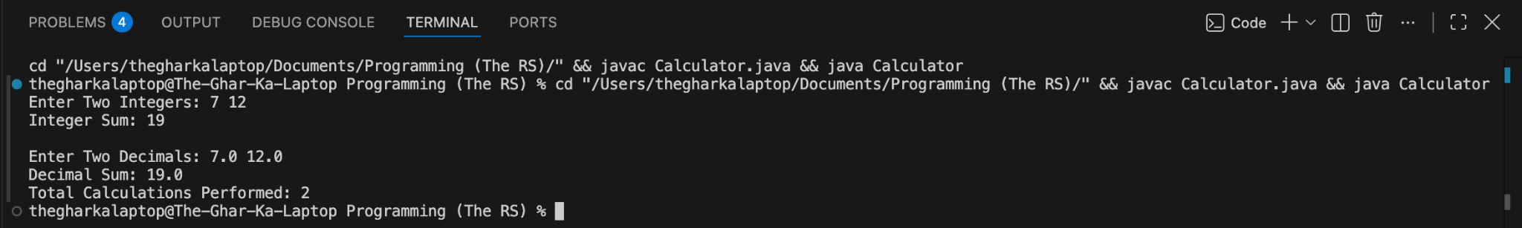

RestaurantBilling.java
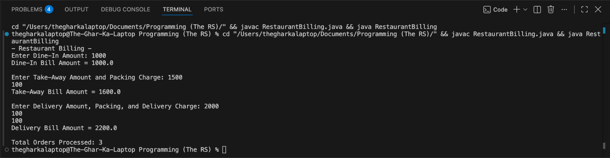

Conclusion:
In this assignment, the concepts of compile-time polymorphism and shared class members using method overloading and static variables were successfully implemented and verified. Method overloading provided flexible function calls with different parameter types, and static variables allowed efficient tracking of shared data across the entire class without requiring separate object instantiation.

